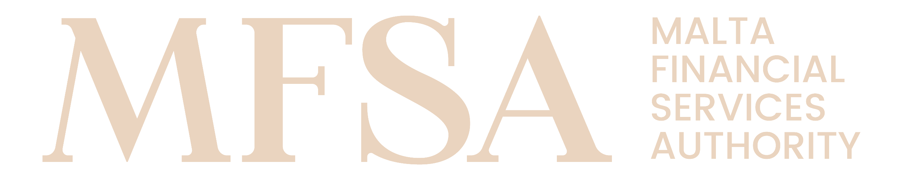
MALTA FINANCIAL SERVICES AUTHORITY
Declaration Form

ANNEX II

Annual Compliance Declaration Form for Mixed Financial Holding Companies and Financial Holding Companies for Approval or Exemption.

  - Declaration
            - Declaration Form pursuant to paragraph 36 of BR/25/2022
The undersigned, declare that:

Enter name of Mixed Financial Holding Company or Financial Holding Company with Company Select item Enter number and vested with the legal representation of the said Select item hereby declare that up to Enter date of submission, Enter name of Mixed Financial Holding Company or Financial Holding Company is compliant with all approval or exemption conditions submitted to the Malta Financial Services Authority (hereunder the ’Authority’) stipulated in article 11B of the Banking Act (Chapter 371 of the Laws of Malta) and the Banking Rule BR/Select item/2022 on Mixed Financial Holding Companies and Financial Holding Companies.

In relation to the above-mentioned declaration, I hereby further declare that:

- the Mixed Financial Holding Company or Financial Holding Company in question is accountable and responsible for the procedures and methods related to the processing, retention, production and transmission of information and, or documentation to the Authority;

- the Mixed Financial Holding Company or Financial Holding Company in question is accountable and responsible to ensure that good quality, reliable and correct information and, or documentation is submitted to the Authority;

- the Mixed Financial Holding Company or Financial Holding Company in question has in place appropriate and adequate verification measures on the processing, retention, production and transmission of information and, or documentation submitted to the Authority;

- the Mixed Financial Holding Company or Financial Holding Company in question implements and carries out adequate and proper checks and controls on the information and, or documentation before this is submitted to the Authority;

- the Mixed Financial Holding Company or Financial Holding Company in question ensures that the information and, or documentation submitted to the Authority is consistent, correct and in line with the information and, or documentation available in the Mixed Financial Holding Company’s or Financial Holding Company’s in question internal information systems.

            - Representatives and Disclosure
- the MFSA is hereby being authorised to make such enquiries as it may consider necessary in connection with this Declaration; and
- the MFSA is hereby being authorised to contact any or all of the above-named or any other person considered by the Authority to be relevant, both at the date of application and at any time in the future unless and until I/we rescind this authority in writing.

            - Privacy Notice
I have read and understood the MFSA Privacy Notice and the terms and conditions included therein.

Signature
Name | Enter name | Surname | Enter surname
Identification Type | Select item | Identification Number | Enter identification number
Position | Enter position within the Mixed Financial Holding Company or Financial Holding Company | Date | Enter date

For further information visit: https://www.mfsa.mt/privacy-notice/

