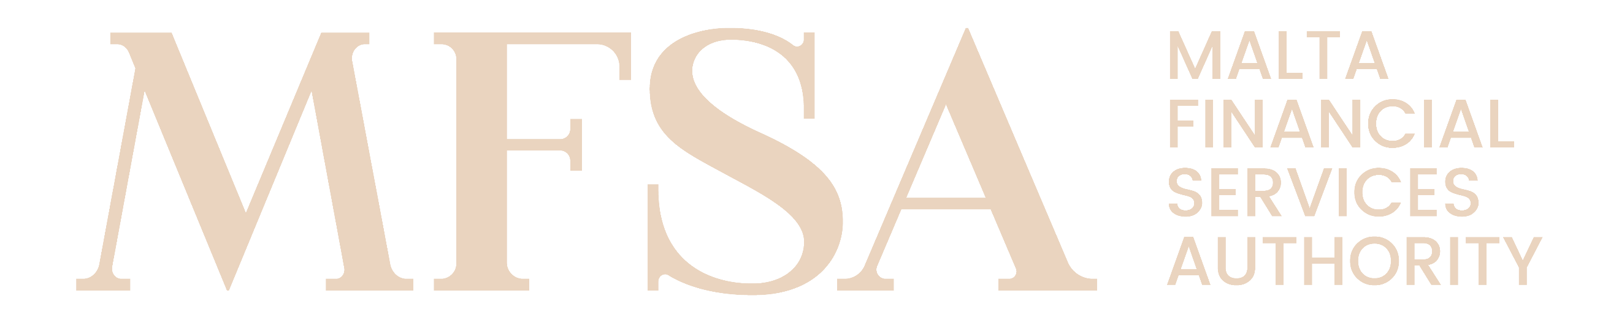
MALTA FINANCIAL SERVICES AUTHORITY
NAIF Notification Form – Annex IV

Declaration Form for AIFM and NAIF Governing Bodies

Name of the NAIF: Enter text
Name of the AIFM: Enter text

AIFM Governing Body Declaration
We, the governing body of the AIFM, hereby confirm that the AIFM acknowledges and agrees that it is responsible for the NAIF’s compliance with applicable law and regulatory requirements, including any obligations arising in respect of the Notified AIF pursuant to the AIFMD.
Signature of the official authorised to sign on behalf of the AIFM
Name | Enter text | Surname | Enter text
Position | Enter text
Date | Enter date
(Add multiple as applicable)

NAIF Governing Body Declaration
We, the governing body of the NAIF, hereby confirm that the NAIF acknowledges and agrees that it is responsible for the NAIF’s compliance with applicable law and regulatory requirements, including any obligations arising in respect of the Notified AIF pursuant to the AIFMD.
Signature of the official authorised to sign on behalf of the NAIF
Name | Enter text | Surname | Enter text
Position | Enter text
Date | Enter date
(Add multiple as applicable)

